College LaSalle
Project – Web Client Development User Manual
Presented to: Mihai Maftei

Author: Puneet Kaur
4/12/2025
Version : 3.0

Describe your application by using print-screen images and a short description (use simple words) to describe the functionality of each page/button/link/field of your web site.

Login Page

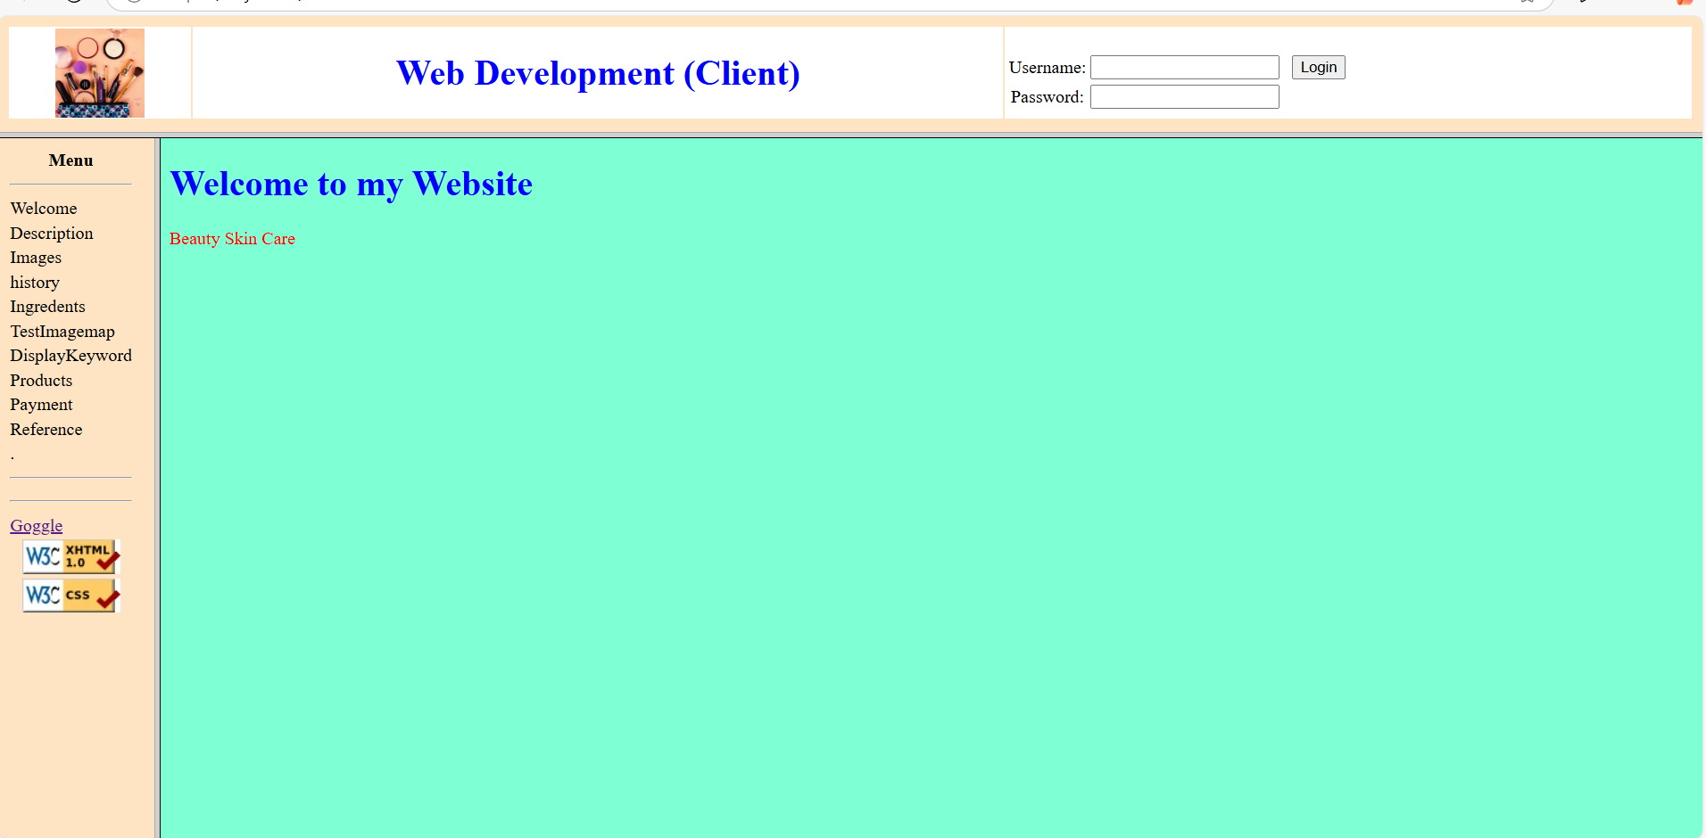
Example:
- Enter your Username and Password to enter my web site. (puneet, 0285)
- Click on one of the links to have access to different applications.
- If you click the link of Google, another web page will open, giving you the possibility to search on the internet.
- To validate web pages like: XHTML or CSS (programmers only), you must use one of those two buttons under the link Google.
- Logon Page Afterlogin

Welcome Page

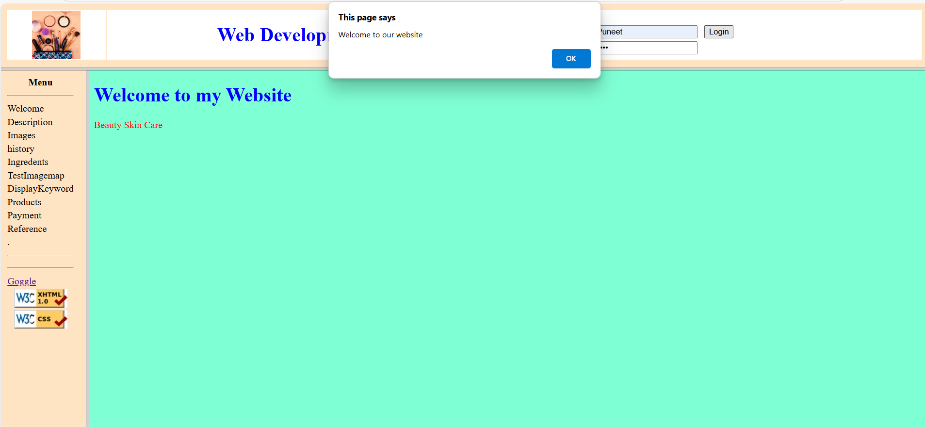

Description Page

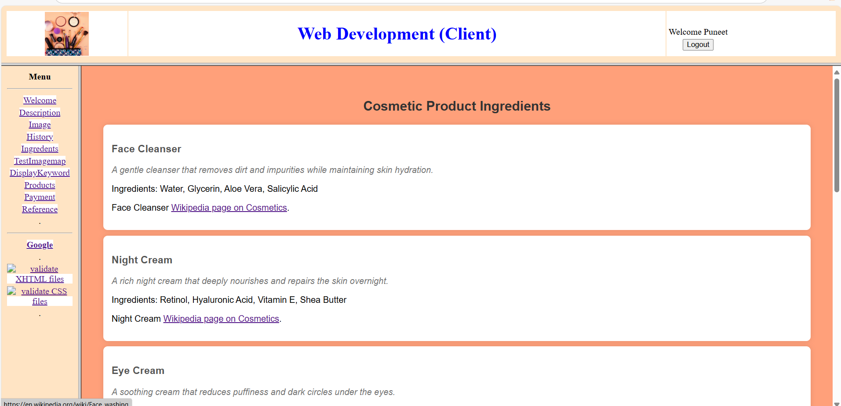
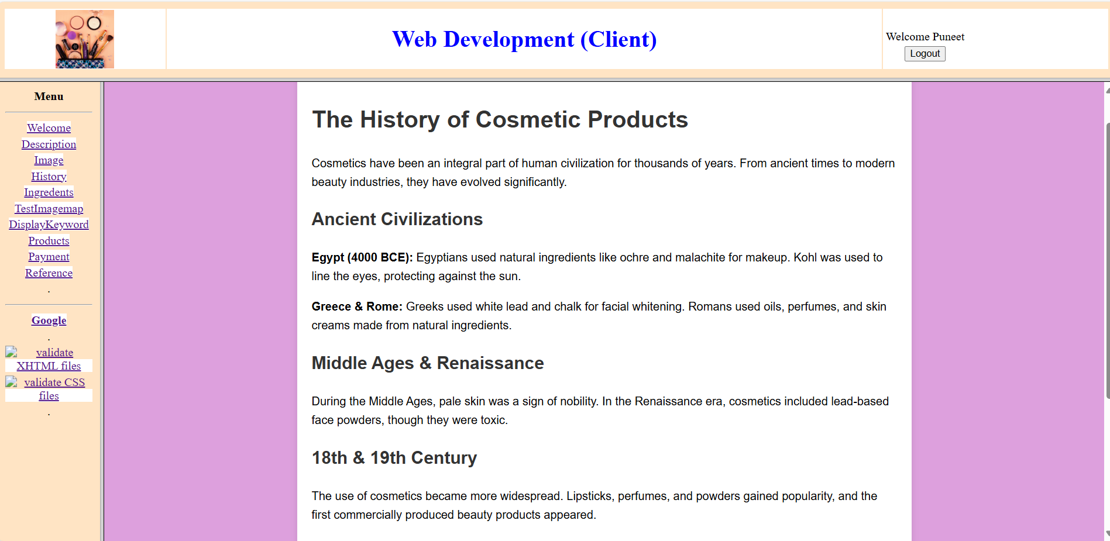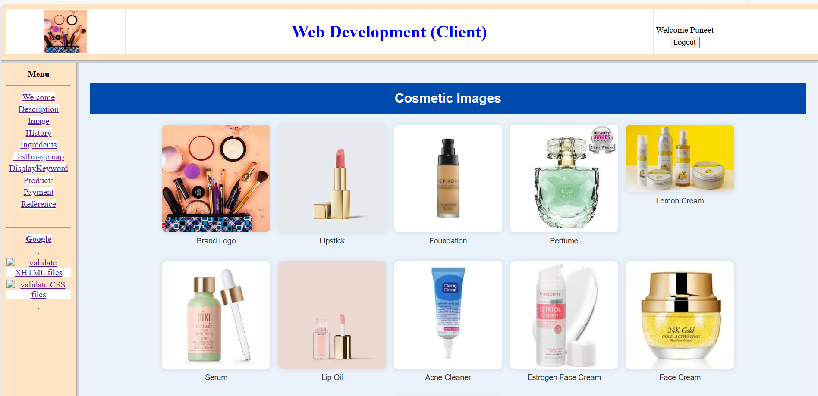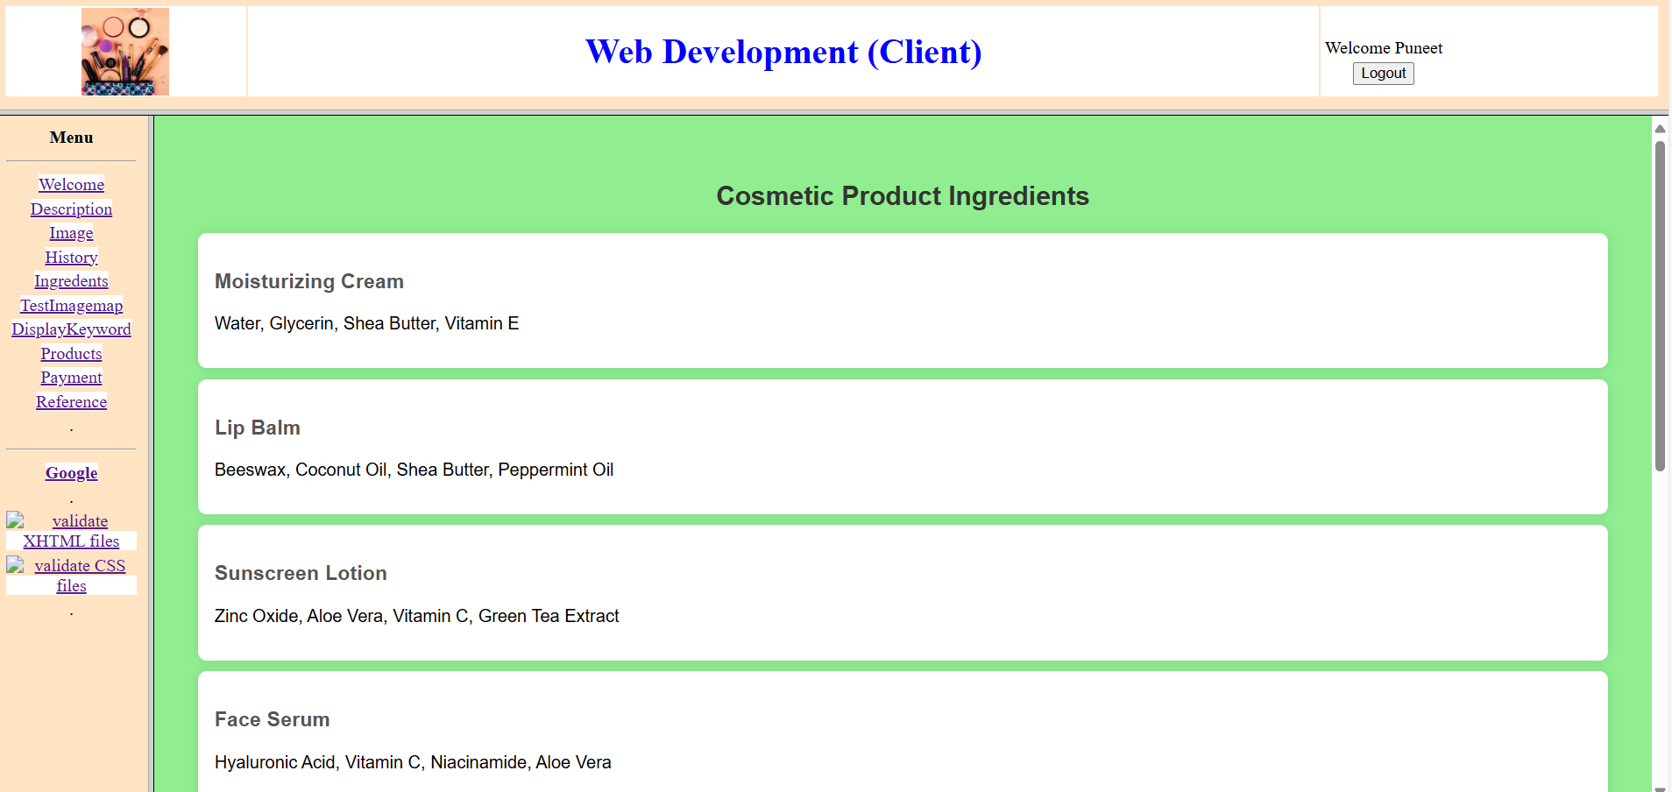

3rd Page Imagemap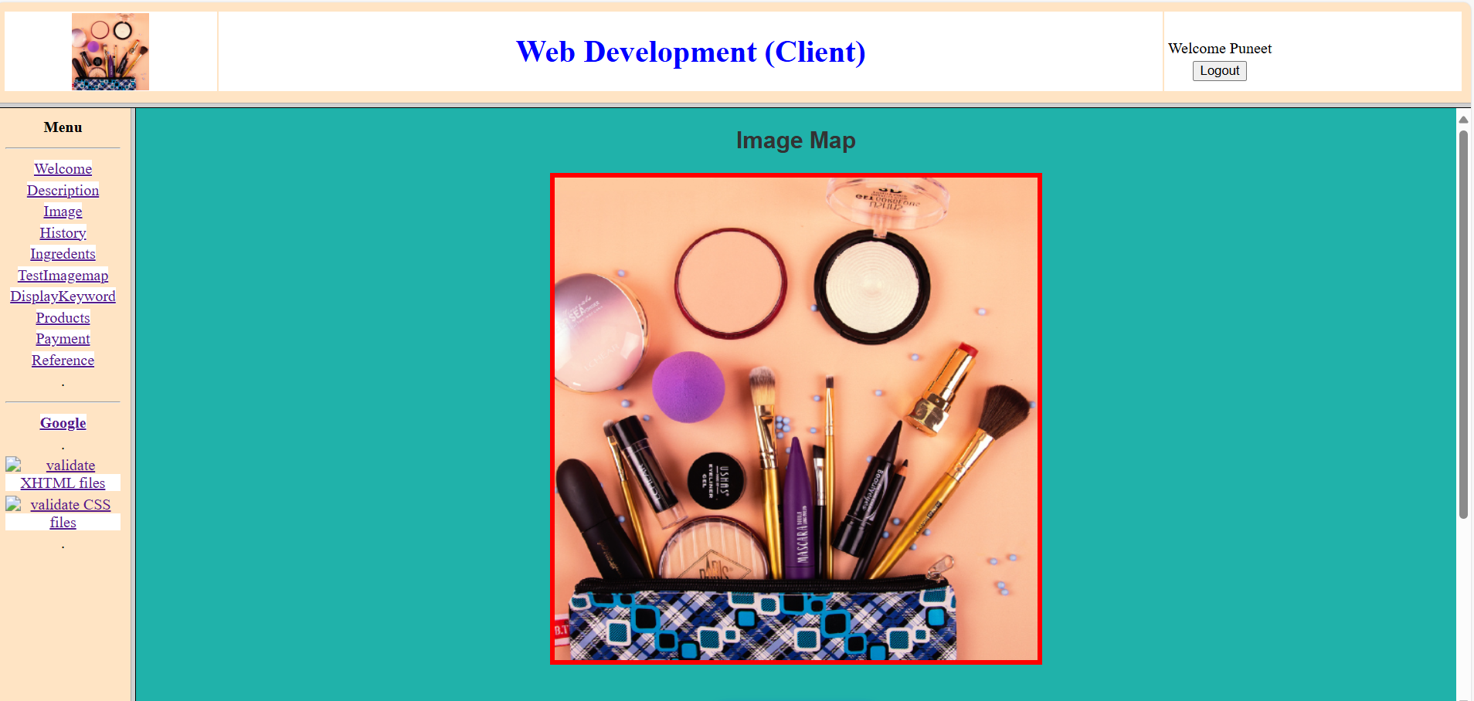
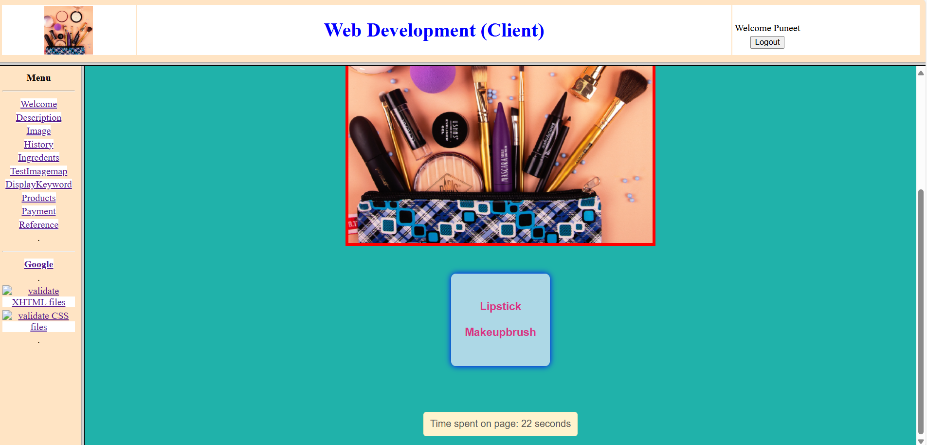

4th Page Keyword Display

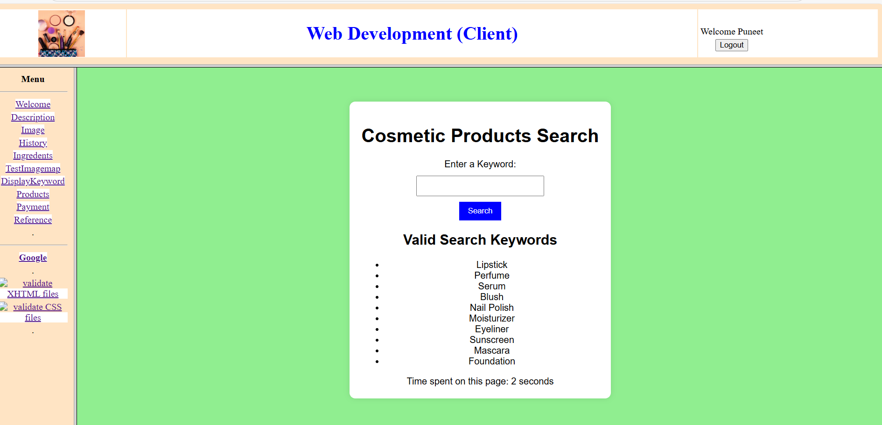

5th Page
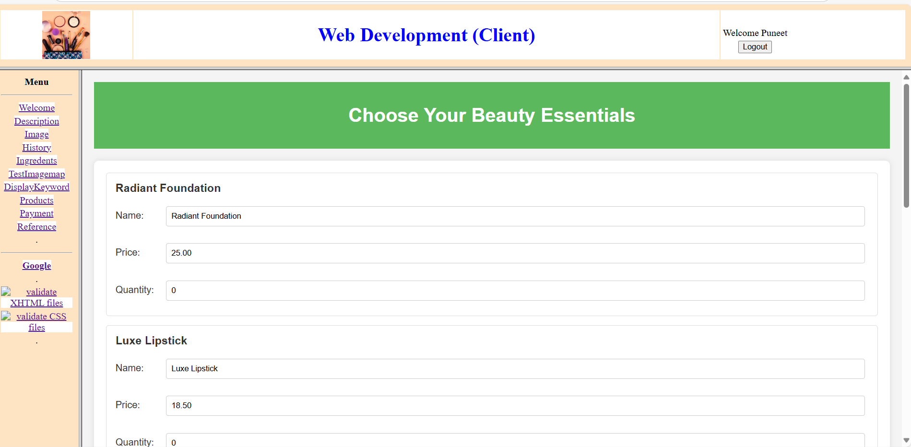
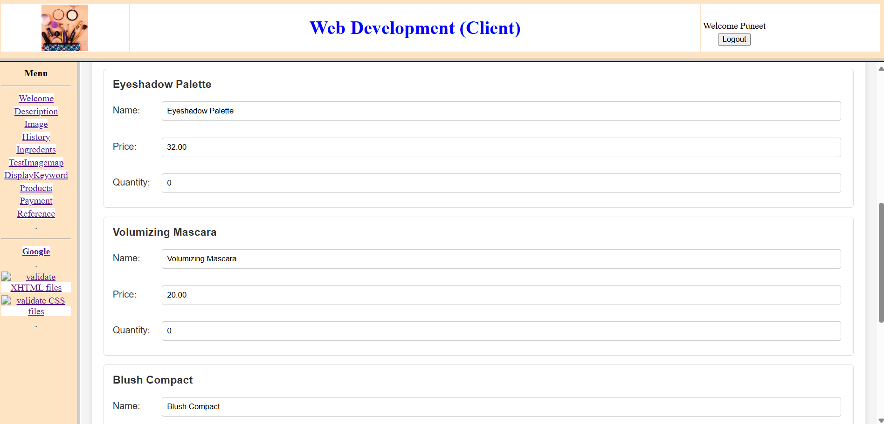
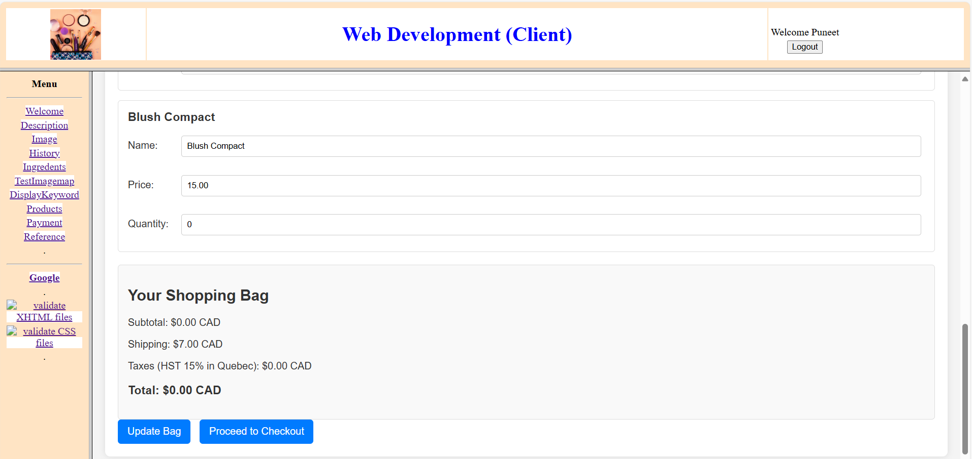

6th Page Payment

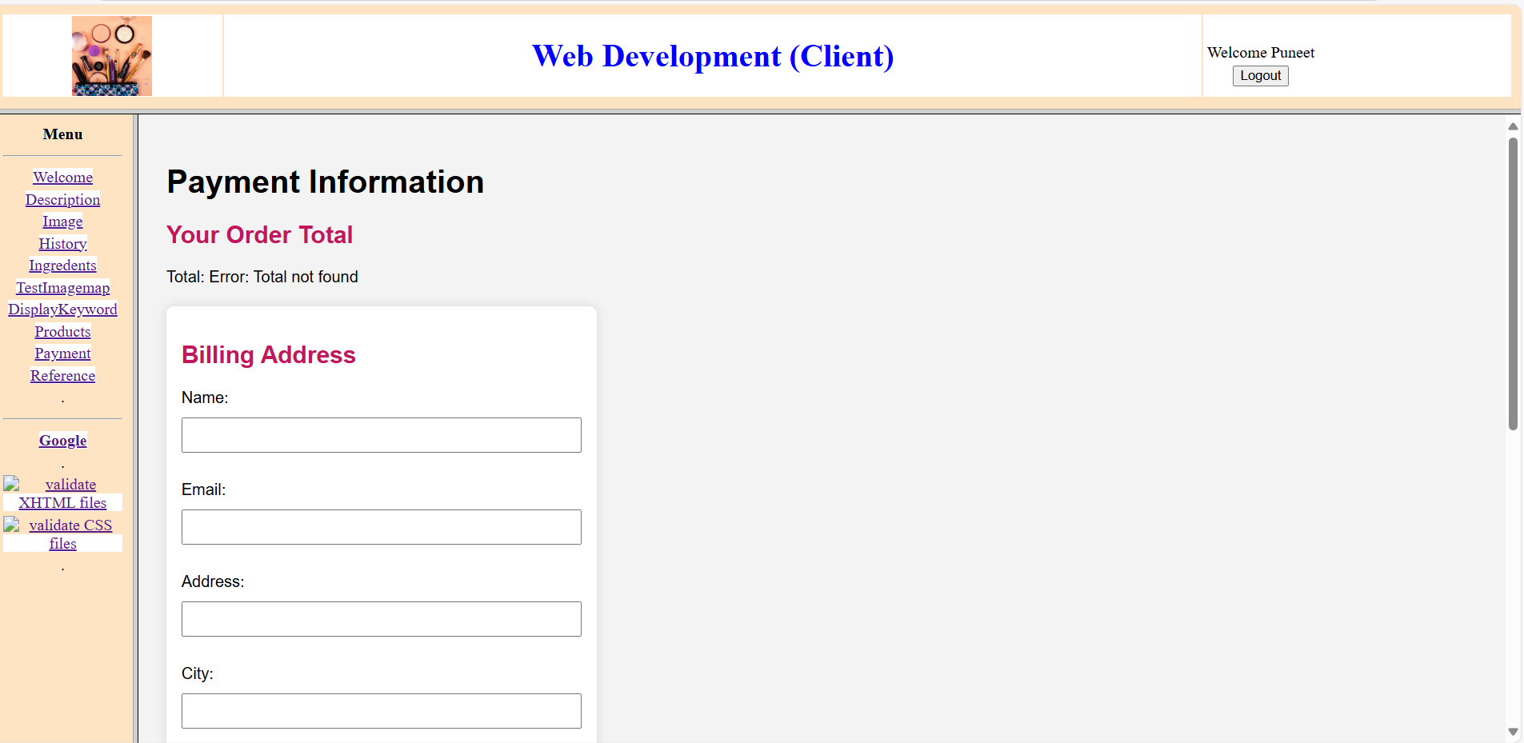
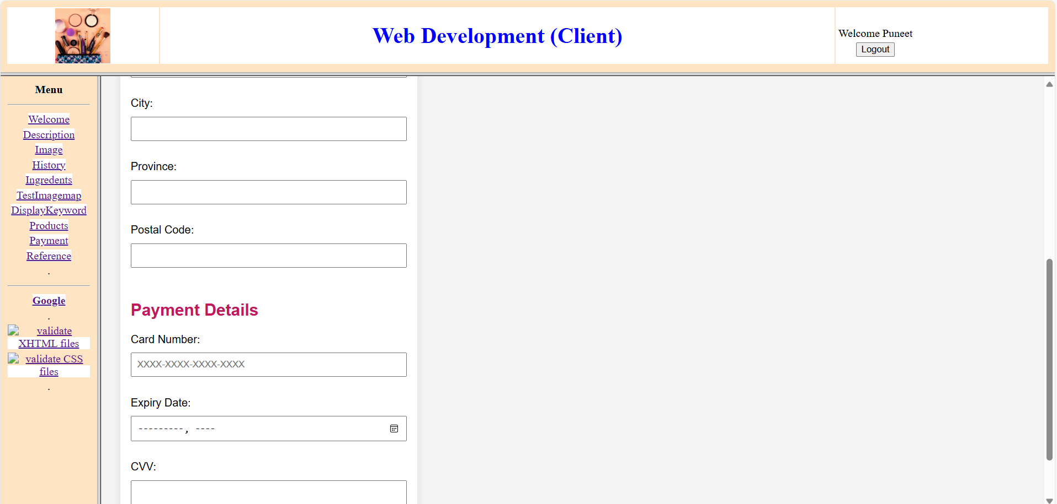
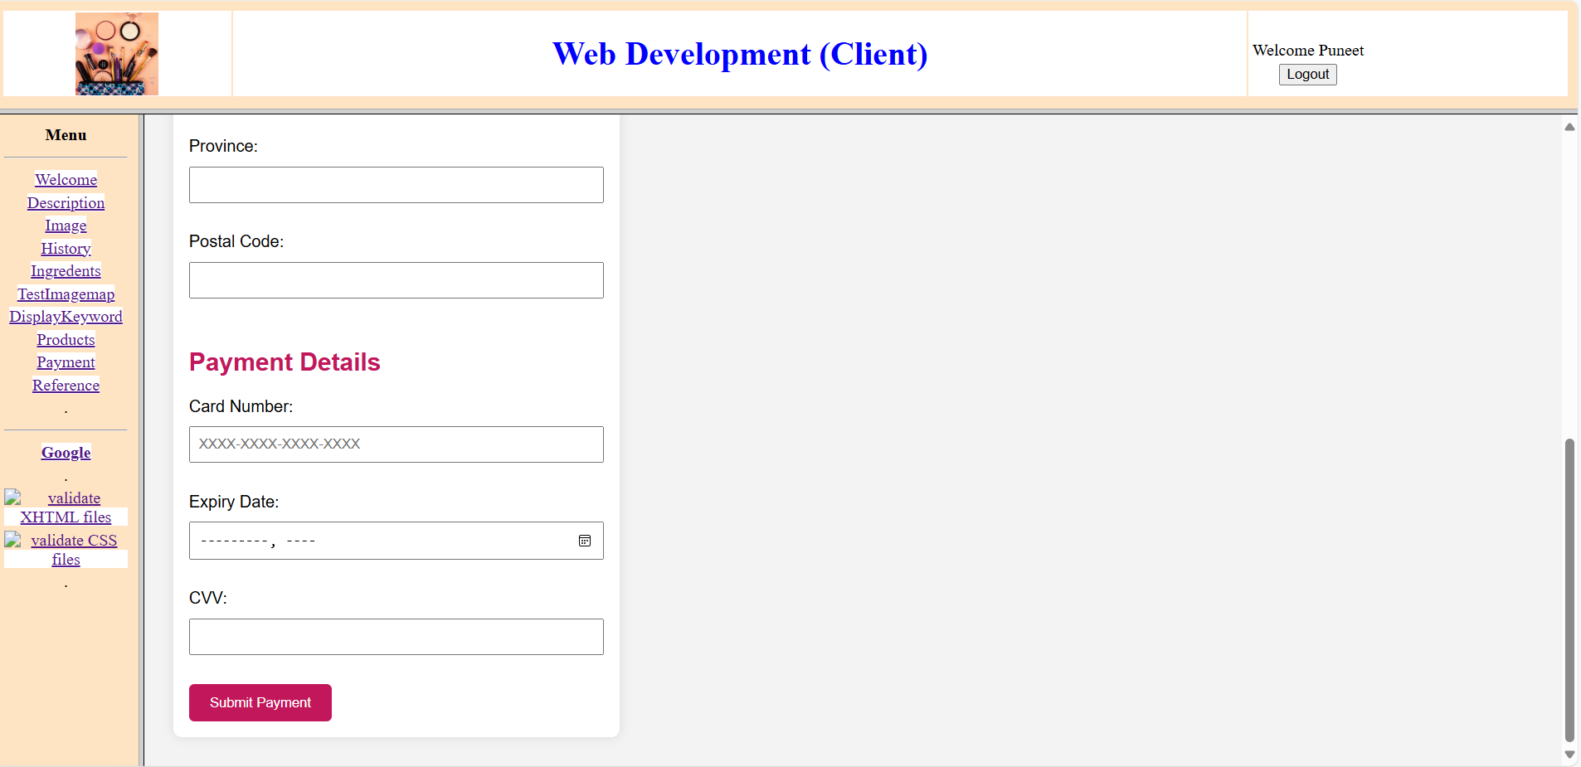

7th Page Reference

